War, regimentation and journalism
By Syed Irfan Ashraf
Thursday, 25 Jun, 2009 | 10:44 AM PST |
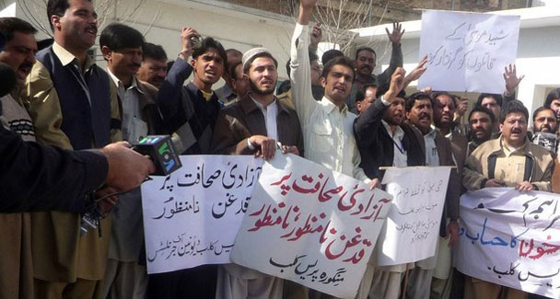
The security of journalists is as important as their independent accessibility to the conflict zones. — AP/File Photo

Metropolitan
Militants blow up girls’ school near Peshawar

CASHING IN
Entrepreneurial begging in ‘IDP industry’

The truth is hard to define — let alone defend — in a society where violence is deeply entrenched. In northwest Pakistan, the task of journalists to report on the current conflict is becoming increasingly difficult.
It is so because neither of the two fighting forces, the military and the militants, give any room for independent reporting in Dir, Buner, Swat and the tribal belt which has practically become a no-go area. The situation has given rise to an information vacuum, fast being filled by a new genre of reporting — ‘rumour-based’ journalism.
It is often said that truth is the first casualty of war. After the Iraq war in the 1990s, John Pilger, an Australian journalist and documentary filmmaker, said journalism — and not the truth — was the first casualty of war. His words aptly represent the scale of damage that journalism has suffered over the last few decades.
In 2003, US warmongers hardly allowed journalists any breathing space lest they washed away the phony arguments used to justify the attack on Iraq. A new term ‘embedded journalism’ was coined. Media men were ‘trained’ by the military before being flown out or taken in tanks to report on the war. Many in the US now draw a parallel between the destruction of Iraq and the lack of objective reporting. They believe that had journalists operated independently, US policymakers would have been in no position to sell the war to the public, based on false charges against Iraq. Because of ‘embedded journalists’ compromising on media ethics in order to prove themselves patriotic Americans before anything else, the US public supported the Iraq war.
The phenomenon applies to Pakistan as well. In the wake of an information blackout because of prolonged curfew hours, journalists are handled by official tour operators who facilitate their visit to conflict-hit zones in military choppers. In this milieu, it is difficult for media persons to ascertain the reality in the deserted town of Mingora or the thick forests of Peuchar. That is why embedded reports carry statistics, briefings, claims and sensational visuals showing the battlefield, but little of the real picture.
Sadly, on such trips every effort is made to keep the journalists away from the locals who can give the facts. On a trip to Darra Adamkhel last September, a tribal elder was asked to talk to me about the brutalities perpetrated by the Taliban in the hilly town. Before he could complete what he had to say, the tribal elder was shouted down and asked to stop by a government official when he said, ‘We don’t know who the Taliban are and where they come from … if the government is lenient towards them, then this storm could wipe out our whole tribal society.’
Given the controlled information regime, real news (in its proper context) has difficulty in getting to the various media outlets. TV channels have multiplied over the past couple of years. But their content is limited to official press releases and phone calls from militant commanders. In other words, it is these forces that control the flow of information. Efforts to put the news in its correct perspective is least tolerated, resulting in the absence of context. Journalists who try to give an accurate picture are increasingly succumbing to pressure tactics.
An example is given of a television journalist reporting in 2007 on the funeral of a mother, her infant and another family member killed by a stray shell at night. He was told by his channel to avoid using the term ‘civilian’ to describe the casualties as the powers-that-be were not happy with the channel’s reporting from Swat. The journalist had no option but to refrain from giving a clearer narrative that would have mentioned the killers and explained why a larger number of civilians than militants were dying in the shelling every night. Obviously, it left viewers confused as to who was killed — the civilians or the Taliban and their accomplices.
Unfortunately, indulging in half-backed information or blatant untruths is not the exclusive domain of official agencies. The advent of TV journalism in Pakistan has seen private media outlets take a step back from professionalism in their desire to be the first with the news. There is little focus on the credibility of the news or the source of it, in part because some media professionals believe that sensationalism sells as a result of the lack of access to the conflict zones.
A local channel once asked its senior reporters to do whatever possible to increase the viewership. The next day, one of the reporters sent a report from Peshawar that the Swat Taliban leader Fazlullah had been killed. When asked why he had provided the wrong information, he replied, ‘Today’s news says he is killed, but tomorrow it will be disclosed that he’s still alive.’ This trend of selling lies has so flourished that the list of 21 Swat militants issued by the NWFP government had on it the names of many commanders who were ‘killed’ more than once.
Similarly, last year a journalist from Bajaur Agency wired the wrong news that Taliban commander Baitullah Mehsud had died. In the next 48 hours, journalists had a field day trying to analyse how he died: heart attack or diabetes? Rumour-mongering continued day in and day out. Meanwhile, other journalists reported wrongly on drone attacks resulting in death and destruction from a calm albeit tense Waziristan. Those adhering to professional norms suffer most as a result. A journalist from the tribal areas once said that he often argued with his foreign producers who wanted him not even to give unconfirmed news a miss. ‘When my sources are not confirming a piece of news, I cannot report for the simple reason that others have reported it,’ said the journalist.
In this situation, it is no surprise that the reality appears increasingly blurred. As professional ethics take a nosedive, journalists with integrity find themselves losing heart, while at the other end, the common man is deprived of truthful information which is his right. Journalists and journalism as a profession are getting a bad name. News associations should come forward and work towards improving conditions and security so that independent reporting from the conflict zones becomes possible. The security of journalists is as important as their independent accessibility to the conflict zones. This will help eliminate the regimentation of media professionals and contribute towards a steady stream of reliable information to our news channels.
syedirfanashraf@gmail.com

