Civilians: first line of defence
By Syed Irfan Ashraf
Monday, 08 Feb, 2010
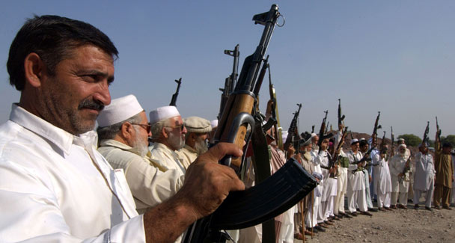

Declared or otherwise, there are nine ongoing operations by the security forces to crush the militants in the NWFP and tribal areas, with at least one in the offing in North Waziristan.
However, while the strikes themselves have weakened the enemy and caused it to retreat to the surrounding hills, subsequent security arrangements have done little to lay the foundation for a durable peace. The militants have not yet called it a day and continue their hit-and-run war. The writ of the state has not yet been established beyond cantonments and garrisoned offices.
Currently, off-and-on explosions, targeted killings and kidnappings have robbed people of their peace of mind. According to NWFP Senior Minister Bashir Bilour, officials from other provinces avoid Peshawar despite the heavy security and relative calm in the provincial capital. Investors remain a distant dream.
Obviously, an effective counter-terrorism strategy is needed in the restive areas. But for this to be effective it is important to cast a critical eye on the present security mechanism in the tribal areas and the province.
One aspect of security is the organisation of lashkars in the tribal belt and peace committees in the settled areas of the NWFP. This has brought civil society face to face with highly trained, hostile and armed-to-the teeth militants.
A suicide attack in Hassan Khel village, Lakki Marwat, some weeks ago is a case in point. Here 120 peace committee members and volleyball fans gathered for a match were killed when a vehicle driven by a suicide bomber exploded. The government had engaged locals to fight off the militants, something which the villagers accepted without assessing the threat to themselves.
The official policy to use civilians as the first line of defence has achieved success in areas where the interests of civil society have synchronised with those of the state. For instance, in upper Swat feudal owners have organised lashkars to protect their orchards and lands.
As the idea of lashkars caught on, this writer spent some days with lashkar members in Gut, Peuchar and Shawar, formerly militant strongholds. Unlike the traditional concept of the lashkar, where a tribe has autonomous powers of decision-making, tribal people in upper Swat were following the government plan to fight the enemy. In a situation where some tribes are ready to be used as sandbags against militancy, is the government justified in forcing others to take up arms against the militants?
In July 2009, the administration in South Waziristan sent the Khasadars to seal the business outlets of the Mehsud tribe in Peshawar. Under the Frontier Crimes Regulations, the tribesmen were forced to stand up against the then top Taliban leader Baitullah Mehsud.
Given the scale of damage in the militancy-hit areas over the last many years, it is vital to address these worries of the tribal people. This is only possible when the state listens to their concerns before foisting its own plans on them. This will help remove loopholes in the existing security strategy and fix compensation for those in the line of fire.
Anything less than this will not lead to the desired outcome and will only result in resentment on the part of the tribes. A case in point is the incident that took place in October 2008 in Orakzai Agency. Over 300 tribal elders had gathered at a roadside ground when a suicide bomber exploded his vehicle to kill more than 150 tribesmen of the Ali Khel tribe.
The injured alleged that the jirga was called in connection with meeting an insensitive government deadline, which demanded that the tribal people raise a lashkar against the militants in their areas or face helicopter gunships and artillery fire.
Had the officials sitting miles away in fortified offices also cautioned the tribesmen to adopt security measures or provided the means to observe these, the tribal agency would have avoided Fata’s deadliest blast. Ironically, such attacks on tribal gatherings in Bajaur Agency, Waziristan, Swat valley, and Darra Adam Khel have killed civilians in their hundreds and dented the confidence of the local people to fight militancy.
In the whirling vortex of mainstream politics, the sacrifices of civilians go unnoticed. People living in the troubled spots have lost one generation of notables, not to mention tens of thousands of homes in Malakand division alone. But hardly any official document carries the figures of civilian lashkar deaths to compensate the bereaved families for the loss of members fighting the war against militancy.
Given the uncertain situation, it seems that despite the retreat of the militants, civil society remains hostage to ‘protective measures’ taken against the Taliban. One wonders how long it will take for the exhaustive bureaucratisation of security measures in the forms lashkars and inconvenient road blockades to end.
Opposition members in the NWFP Assembly demanded that the ANP government open the Kohat tunnel closed for the last two years to traffic in the evening. This tunnel on the Indus highway is the main passage linking the northern frontier to the south of the country. The enraged opposition in the assembly complained that the province had been handed over to the law-enforcement agencies.
Understandably, civilians hold the key to winning the war on militancy and their cooperation is indispensable in this regard. But Talibanisation is not the product of civil society nor should civilians be forced to eradicate the menace from their areas in a manner that constitutes a serious threat to their own lives.
The state itself should be showing greater seriousness in fighting militancy before telling civilians to take on the extremists to achieve its security goals. This will help restore public confidence in state policies. Also, before taking any party on board for combat operations the cost and benefits of a counter-terrorism strategy should be made amply clear.
But as a first step it is important that a counter-terrorism strategy be debated in parliament to calculate the cost of militarising civil society. Past experiences have shown us the hazards of raising private armies — even if it is for a just cause.

