Defence: a grey area
By Ayesha Siddiqa
Friday, 10 Jul, 2009 | 07:56 AM PST
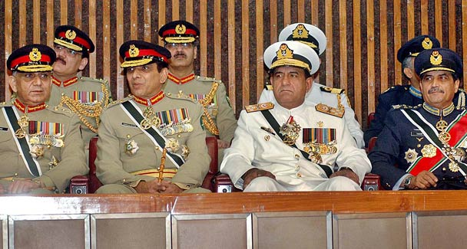
It is time we took another look at our military strategy and weapons-procurement planning which suffers from major flaws starting from the absence of a rational procurement planning loop. —APP/File photo
DECISION-making in the defence sector is generally a grey area because of the secrecy that surrounds the process. However, in decision-making environments where political and accountability systems are not strong, there is greater vagueness.
Two questionable deals in this country involve equipment for the Pakistan Air Force (PAF) and the Pakistan Navy (PN). In the PAF’s case, former air chief Kaleem Saadat claimed that Gen Musharraf ruined a $1.2bn deal to acquire Swedish surveillance aircraft. The second instance concerns President Zardari’s alleged link to financial mismanagement in negotiating a deal for new submarines.
According to the current procedure, different directorates in the services headquarters are involved in evaluating weapons’ requirements and then coming up with staff requirements which are evaluated by the planning departments in their respective headquarters. The army’s system is more elaborate than that of the other two services. Once the service boards shortlist their requirements the latter are communicated to the Joint Chiefs of Staff Committee (JCSC) to prioritise the procurement of arms for the three services. This is then communicated to the government through the defence ministry.
The army chief has a lot of influence in the JCSC. This has especially been the case over the past decade because of changes in the system where the post of chairman is occupied by an army general. The position no longer goes to the other services. The contract is taken care of at the defence ministry where officials from their respective service headquarters and posted in the ministry assist the process.
In this system, the head of state, especially if he is also the army chief, plays a major role. As army chief, the president can influence the final selection. So Gen Musharraf was in a position to influence the contract and the final acquisition.
But what about Asif Zardari who was also accused of making money in the past from the acquisition of the French Agosta-90B submarines? It is worth noting that the Musharraf government could not get any real evidence of Benazir Bhutto’s and Asif Zardari’s involvement in the submarine deal despite pulling up former naval chief Admiral Mansoorul Haq. It is important to note that while the previous PPP government could be linked to questionable power-sector deals, it probably had less to do with defence purchases. In any case, the procurement process is longer than the average life of a political government for a single person to influence the decision.
This is not to say that the PPP is above board. This is simply the nature of the defence acquisition system. Any financial mismanagement in defence deals has to involve military personnel at the service HQs and the JCSC. According to the prevalent procurement system, the acquisition of weapons depends on staff requirements decided at the service headquarters. The ‘higher defence reorganisation’ planned under the Bhutto government during the 1970s had made the defence ministry responsible for all weapons-procurement administrative work such as calling for bids, floating tenders, writing contracts and negotiating with sellers.
Ideally speaking, staff requirements must reflect the needs of a service. These muse be based on tactical, operational and strategic intelligence. The defence ministry should be responsible for fine-tuning staff requirements and finding the right system to meet the service’s needs.
Currently, the selection of weapons is done at the services’ headquarters which means there is greater interaction between the divisions responsible for planning and potential sellers. Resultantly, staff requirements also reflect the bias of the procurement team for a specific seller. This is where money is to be made. It is after overt and covert deals have been taken care of that the case is passed on to the government.
Where the PN and PAF are concerned obtaining approval for a major acquisition depends on the interest shown by either the army or the head of the state, the final authority. The air force has been luckier than the navy due to the relevance of the service to the army-dominated military strategy.
With the largest service overly involved in politics, governance and now internal security, the PAF is considered vital to fighting a potential war with India, a concept that dominates our military strategy. On the other hand, the PN, which has less strategic significance, tries to attract top policymakers. There are fears that this could be done through offering them a share in the money. The top management influences the naval staff requirements and the final selection of weapons.
This has happened in the case of the acquisition of the P-3C Orions for which the PN has no naval staff requirement or NSR i.e. no real demand has been generated for the aircraft. Another case refers to negotiations with the Chinese for the F-22P frigates in which the service chief overrode the decision, despite issues raised about the technology by relevant quarters.
There are some that suggest that the appointment of a relatively junior District Management Group officer as ambassador to Paris is meant to facilitate a deal with the French. Such claims do not take into account two factors. First, an ambassador is too insignificant in the entire procurement process to influence a deal which the defence establishment including the ministry of defence manages. Second, the PN’s existing submarine fleet is of French origin.
Changing the source would mean adding to the cost as it would involve setting up newer maintenance and other facilities. Not to mention the fact that Islamabad acquired the Agosta-90B under a transfer-of-technology agreement which not only escalated the cost of the deal but also meant that the PN could make additional submarines. The capital investment in the acquisition of weapons represents about 12 to 15 per cent of the lifecycle cost of the equipment. In simple language, a larger array of weapons in terms of their source will add to the overall cost of equipment without increasing efficiency.
It is time we took another look at our military strategy and weapons-procurement planning which suffers from major flaws starting from the absence of a rational procurement planning loop. Weapons’ procurement suffers from the absence of a ‘system’ that actually qualifies as one. Unless one is introduced, we will keep losing money to corrupt bureaucrats and leaders.
The writer is an independent strategic and political analyst.
ayesha.ibd@gmail.com

