Downhill for Pakistan?
By Tariq Amin-Khan
Tuesday, 19 Jan, 2010
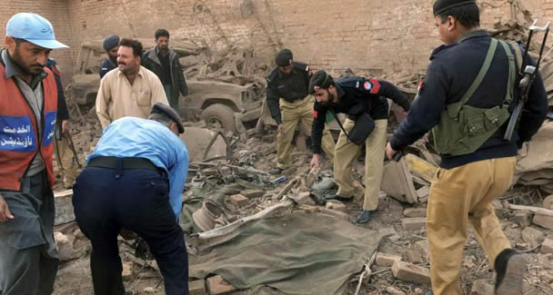
The long war brings in its wake some terrible consequences in terms of untold death and destruction.

The CIA recently lost its forward operating base in Khost. Pakistan is under pressure to attack North Waziristan. And the noise about redrawing Pakistan’s borders has increased by a few decibels.

Imperial machinations may desire such an outcome, but its realisation will depend on the internal dynamics of state and society. The latter alone can actually make or break a state. But what happens if the state is imploding?

Recently, Zardari’s civilian government raised the spectre of the country’s dissolution by actively but unsuccessfully playing the Sindh card. Zardari denies doing this, insisting that he has Pakistan’s interests at heart, yet threatened to invoke the Sindh card. If Sindh has not descended into chaos and bloodshed despite the inflammatory speeches of PPP leaders, this speaks of the sagacity of the people living in the province.

Pakistan’s survival as a viable state, though, depends on how the current conjuncture is negotiated: whether the 17th Amendment is rescinded; the courts are respected and the culpable and the corrupt are prosecuted; the problem of social neglect and public disservice is tackled; and that someone among the rulers finally stands up to the US rather than prostrating before its imperial diktats.

These are the minimum steps needed to preserve Pakistan. But the bankruptcy of the current leadership is its inability to develop a sense of urgency in tackling the country’s enormous problems.

Under Zardari, the security situation has gone to the dogs not because the military is going after the Tehrik-i-Taliban Pakistan (TTP); rather, these horrifically random suicide attacks are a result largely of incompetence, sloppy intelligence and the lack of coordination among different security services. Incredibly, there were more suicide bomb attacks during 2009 in Pakistan than in Iraq.

Zardari’s government has allowed Pakistan to be a veritable playground for Blackwater/Xe, US Special Forces, a much-expanded US embassy ‘staff’ and complex (mimicking Iraq’s Green Zone), and the trigger-happy controllers of aerial drones. Collectively, these boys with their deadly toys will wreak further havoc in the country.

Furthermore, cowing before the demands of the US and the western world to ‘do more’ has been unprecedented under Zardari. He has effectively given a blank cheque to the Americans, while unprotected ordinary Pakistanis are left to face the fallout from his and the military’s commitment to wage US’s ‘long war’ (Pentagon’s language for the ‘war on terror’).

The long war brings in its wake some terrible consequences in terms of untold death and destruction, unleashed as state militaries confront non-state players such as the Pakistani Taliban.

This is not to say that the TTP should not be confronted, but it can’t be at Washington’s prodding. There cannot be two views about the havoc and human suffering caused by the TTP and their pernicious anti-women and anti-people violence, but the strategy to confront them has to be an indigenously developed mix of social, political and military responses.

Beyond the internal dimension, external forces are imposing other indignities. One such xenophobic measure on which an edict was passed almost immediately following the failed bombing attempt over Detroit concerns travellers to the US from Pakistan and 13 other states. Respectable people from these ‘bad’ lands, seen as ‘people of interest’ from ‘terror-linked’ states, will now be singled out for additional scrutiny and invasive security checks.

In addressing the consequences of the Christmas Day event, Obama missed an opportunity to mend fences with Muslims around the world by taking a fresh approach. Instead, he chose to take an old page from Bush and the neoconservative’s white book of militarism.

As a result, indignities unleashed since Sept 11 have intensified as the fortress mentality of North America and Europe becomes increasingly white supremacist. Immigrant communities in the West, especially Muslims and people who look like Muslims, have faced a sustained and systemic campaign of racist profiling and targeting in an environment of xenophobic racism.

More troubling, though, is that the long war has become a perpetual war. The inevitable troop surge in Afghanistan is one indication. The war’s expansion into the Middle East and Africa is another. However, this perpetual war is placing an imperial chokehold on Pakistan.

As the troop surge begins, it will worsen the existing state of horrendous insecurity and instability in the country — as if what is already happening is not cataclysmic. In the face of this maniacal violence, the US impositions, the paralysis of the Pakistani state and the challenges to the country’s survival are truly unprecedented.

Remarkably, this current state of instability has provided ample grist for the mills of western military planners and think tanks to dream up a host of scenarios: from imagining Pakistan’s demise to the destruction of its nuclear assets.
One such scenario has the Canadian military preparing a contingency plan to contain street battles in the provinces of British Columbia and Ontario whose cities are predicted to be in flames — courtesy of the conflict scenario that has Canadians of Pakistani and Indian descent at each other’s throats (Toronto Star, Oct 17, 2009).

The Canadian military planners expect that Pakistan will collapse by 2016, and the territory will be occupied by India. Sound bizarre? Not so to the security analysts in Ottawa.
So, is everything downhill for Pakistan? It does not have to be. When all is said and done, the best-laid imperial plans, conspiracies and campaigns are no match for an internally cohesive society, especially if a visionary leadership refuses the $7bn US minefield developed as the Kerry-Lugar Act, prioritises people’s wellbeing while respecting the rights and diversity of the respective ethnic/national groups, and strives for an honourable existence with its neighbours on the basis of regional cooperation.

Given that the present leadership is incapable of promoting these ideals, the Pakistani people will have to decide whether they will roll over and submit or come together and resist. My view, based on the people’s epic struggles for justice, is that they will choose the latter.

