Clear and present danger
By Gul Bukhari
Monday, 14 Dec, 2009
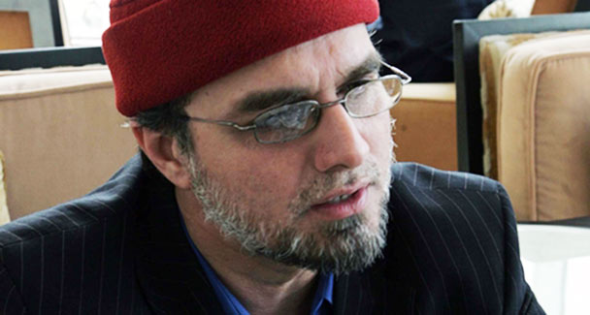
Demagogues like Zaid Hamid are playing the game unchecked and unchallenged. The political and military leadership, including President Asif Zardari, Interior Minister Rehman Malik and army chief Gen Parvez Kayani, is being painted as a traitor for fighting militancy.
Belief in conspiracy theories focusing on Pakistan is not only new, it is on the increase judging by the content of public blogs and TV talk shows.
One comes across a staggering number of people who are unwilling to look inward, instead placing all the blame on any combination of the CIA, the Federal Reserve, Mossad, RAW, the US, etc.
One natural reaction to this is to dismiss conspiracy theories as a folly present in every society. Still, in developed countries conspiracy theorists and their subscribers remain at the fringe.
In Pakistan’s context, conspiracy theories are on a different scale with different implications. Going by blogs, television and anecdotal conversations with educated and illiterate people, I would surmise we are talking about a frighteningly large proportion of the mainstream. Indeed, it is common to blame the Hindus and Jews for Pakistan’s security problems; the US, Blackwater and CIA for suicide attacks. And there is a total absence of introspection.
Why is the problem on such a large scale in Pakistan considering there are parallel demagogues in other countries? Why is the Pakistani public more susceptible than its western counterparts?
The answer can only be based on common sense since studies on the issue do not exist. The country is underdeveloped, lacks a decent social and physical infrastructure, its people don’t have access to economic or educational opportunities. Living in a war theatre, they face food and water insecurity and see themselves as victims.
Victims of whom, though? Not of themselves, no not even in part, but of the perfect villain (the US, Israel, India…), they are told by our local demagogues. And the reason? Pakistan is a Muslim country, and all the villains are waging a war against Islam. These conditions make for a fertile ground for the breeding and dissemination of conspiracy theories.
Once the black and white of it has been established, and the foreign culprits, states and agencies identified and accepted as the villains, any cooperation by the government with the evil forces is seen in the same light. This extends to fighting terrorism. Well-known proponents of conspiracy theories are continuously reducing complex geopolitical issues the country is in the middle of to simply a matter of Islam vs the West (also Israel and India). And on this canvas depicting the epic battle between Islam and the West/Zionism, our political and military leadership is being painted as ‘agents’ of CIA and the US.
The implications are grave. The common man is being prevented from seeing homegrown jihadism as a fundamental part of the problem. A housewife recently phoned in to a popular television programme on a day that a suicide bomber killed scores and, piously expressing her grief without condemning the act, said, ‘but first tell me who is behind all this?’ This attitude is typical.
As the spectre of imminent doom (the Taliban’s entry into Buner) receded some months ago, thanks to the current government and the armed forces undertaking to decisively push back the extremist insurgency, people started to lapse into their dimly lit comfort zone of conspiracy theories. Why? Because neither have the enabling conditions changed, nor have the leaders and proponents of conspiracy theories been confronted.
Demagogues like Dr Israr Ahmed and Zaid Hamid are playing the game unchecked and unchallenged. The political and military leadership, including President Asif Zardari, Interior Minister Rehman Malik and army chief Gen Parvez Kayani, is being painted as a traitor for fighting militancy. The implication is that by pitting the public against these symbols of the state, and the state’s battle with militancy, conspiracy theorists are turning the public against the state itself.
This is not the Pakistan of yesterday when great games were played and deals struck behind the public’s back, when the media was largely gagged and underdeveloped and, therefore, public opinion did not matter. If a war had to be fought, it was fought, and only sold as a jihad later on to the unknowing public, as Gen Ziaul Haq did in Afghanistan in the 1980s.
Today public opinion matters, as was evident in the case of Chief Justice Iftikhar Chaudhry’s reinstatement, the demise of the National Reconciliation Ordinance, the repeal of governor’s rule in Punjab and the current reshuffle of some members of the federal cabinet. For this reason, the implications of conspiracy theories pitting the public against the state on a wide scale are grave.
In the media, there are two parallel universes operating, seemingly unaware of the existence of the other. That section of the media and analysts that carries on a rational debate on issues completely ignores conspiracy theorists. The other section, made up of specific anchors, columnists and programmes, carries on with these theories as if a rational world does not exist.
There are rare exceptions, for example Dawn columnist Nadeem Paracha’s solid response to Zaid Hamid’s theories, or Fasi Zaka’s excellent pieces on the subject about a year ago. But sadly, their words would have only reached the already converted.
The widespread culture of conspiracy theories, increasingly taking on an anti state complexion, is the ticking time bomb of today. It cannot be ignored. The two parallel universes of the Pakistani media must collide, and it is the rationalist section that must catalyse the confrontation — it is not in the interest of the other to do so.
It is imperative that space is reclaimed from conspiracy theorists, for the security of the state is threatened by it. Conspiracy theories are a clear, present and internal danger and the media must take direct action. For only the media and rational elements within civil society, be they defence analysts, politicians, lawyers, retired or serving servicemen, retired judges, cabinet ministers or ambassadors, can fight it. Such credible rationalists from civil society must be invited by the media to help fight this monster. This is an enemy that the security agencies cannot fight off.
Elements in our political leadership, like Punjab Law Minister Rana Sanaullah of the PML-N and Senior Minister NWFP Bashir Ahmed Bilour of the ANP, would also do well not to fan the ‘blame India’ trend for the sake of political expediency. Unfortunately, India is an easy target as it provides a ready excuse for security lapses, absolving to an extent the provincial and federal governments of the responsibility to ‘do more’.

