Demystifying mysteries
By Ayesha Siddiqa
Friday, 01 Jan, 2010
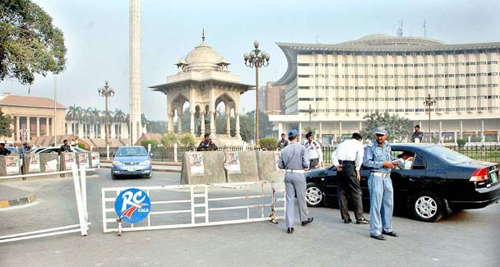
“Every other day there is some news of suspicious cars being stopped by the Punjab police and the passengers being interrogated and then released under pressure from unknown and unnamed people in the government.” – Photo by APP.
The Pakistani media is playing its role by informing citizens about the threat posed by the American security contractor Blackwater. Every other day there is some news of suspicious cars being stopped by the Punjab police and the passengers being interrogated and then released under pressure from unknown and unnamed people in the government.
Intriguingly, we never get to hear the end. There are several questions that could be asked about what the occupants of these vehicles were doing in Pakistan. More important, why does the Punjab government and its police let such people go?
Although the impression one gets from such news items is that phone calls that facilitate the release of presumably American security personnel or private contractors are made by high-ups in Islamabad, the fact remains that it is the Punjab police and government that are responsible for the release of these people.
It would be highly appreciated if newspapers and television channels also reported details of such cases — for instance, the exact identity of the people in these cars with tinted glass. Are they Americans visiting Pakistan on some secret CIA mission? Or are they simply American or other western contractors and consultants working with the Pakistani government?
Most possibly these people are stopped and then released because they cannot be searched under international conventions with regard to diplomatic immunity. Diplomats do not include every American national or private contractor, but foreigners who are providing some assistance to the government of the host country. This is not something specific to Pakistan. It is there all over the world. Therefore, the Punjab police, which these days is imbued with the ambition of fighting American culprits, finds itself unable to take any concrete action against the people they stop. They cannot check a vehicle covered by diplomatic immunity.
Or perhaps the provincial government does not want to clarify things as it could benefit from the windfall of bad publicity for the central government in Islamabad which is both a partner and a main rival of the PML-N. Possibly, the party in Punjab and the military establishment might tone down their criticism of the US once they are in charge of the government again.
It is worth remembering that the first Nawaz Sharif government was eager to assist the US during the first attack on Iraq. This is not to suggest that some strategic divergence in policies will not continue but the conflict could be kept away from the public eye as is happening at the moment.
While the Punjab police is extremely belligerent towards the presence of US personnel in the province, top leaders are involved in carefully managing the threat posed by jihadi outfits. In the past, there was a divide between how the federal government and the establishment and the Punjab government perceived the terrorist/extremist threat. Currently, given the rise in anti-US hype, options available earlier to the provincial and central governments have closed. Any individual desiring to hang on to power in government will have to conform to popular military-strategic norms if he/she has not already done so.
It is also a fact that there has been a formidable rise in the number of American personnel in the country. These may not necessarily be CIA spies planning to kidnap A.Q. Khan or take over nuclear warheads. The number of foreign consultants, advisers and security personnel has increased over the past three to four years. This is due to different reasons such as management of aid and development projects provided after the earthquake, the new aid package negotiated by the present government and increased engagement between Pakistan and the US because of the diversion of international attention from Iraq to Afghanistan and, hence, South Asia.
Aid donors tend to use their own people for aid management due to corruption concerns in the recipient country. Though questions could be raised about how development assistance is planned and distributed in recipient states, the fact is that foreign countries have been increasingly sceptical of the capacity of successive governments in Pakistan to distribute aid.
There are a lot of people in the country’s intelligentsia who were critical of the government’s handling of development assistance. Now everything seems murky given the cloud of fear and insecurity vis-à-vis the US. A popular perception in the country is that the US is out to destroy Pakistan. Such insecurity coincides with friction between the political government and the military on the one hand, while on the other it represents a critical time as what happens in the coming months in Afghanistan and Pakistan will have a bearing on the war on terror.
The Obama administration’s AfPak policy seems to be a mixed bag of clarity and confusion on how to deal with both Kabul and Islamabad. Given the limited options available and Pakistan’s centrality in the war on terror, Washington seems to constantly play the carrot and stick game which only leads to one step forward and one step back.
Meanwhile, the spectre of negative public opinion in Pakistan is extremely useful in providing Rawalpindi with multiple options to tackle various players at the same time. In fact, public opinion limits the options for the partners rather than the players in Pakistan. It has certainly proved fruitful in rolling back the strategy of the political government in Islamabad which clearly understands that while it could play an aggressive battle with political actors, it has to limit itself to military-strategic and geo-political options favourable to the armed forces.
So, the days of a Washington-Islamabad partnership that would be aligned with American interests are over. All key players of the cabinet would rather do what helps them survive personally. The Zardari government’s were naturally limited after it developed a bad reputation not just in terms of financial mismanagement but also of compromising national interests. This is something that does not go down well in circles or segments of population driven by the idea of a strong security state.
Such games do not serve the country’s interests and consequently weaken the state. This is not a prognosis about the country breaking up but about its emotional health. Pakistan will probably survive the current crisis physically. But whether we can as a nation survive the crisis emotionally is another matter.

