Drone attacks: what is America doing in Pakistan?
By Samira Shackle - 07 January 2010

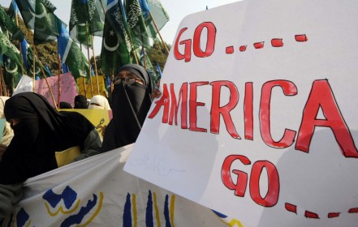
Supporters of fundamentalist party Jamaat-i-Islami protest in Lahore, December 2009. Photograph: AFP/Getty Images
Seventeen people have been killed in two US drone attacks in North Waziristan, a tribal area and Taliban stronghold in Pakistan. The body count is still growing from the attacks, targeted at a compound alleged to be a militant training camp.
These latest attacks are part of an expansion authorized by Barack Obama last month, in line with the troop surge in Afghanistan. It's a policy that is anything but transparent.
For the uninitiated -- what is going on? Well, the first attacks were launched by George Bush in 2004 as part of the "war on terror". They feature unmanned aerial vehicles firing Hellfire missiles (that's actually what they're called, I'm not embellishing) at militant targets (well, vaguely), and have increased in frequency since 2008.
Top US officials are extremely enthusiastic about the drone attacks. They stated in March 2009 that the strikes had killed nine of al-Qaeda's 20 top commanders. High-profile successes such as the death of Baitullah Mehsud, the former Taliban commander in Pakistan, have no doubt given further encouragement. The attacks' status in international law is dubious but, hey, when has that ever been a concern?
Yet in terms of how the Pakistani public might receive it, it is an incredibly reckless policy for the US to pursue, and for the discredited Islamabad administration to allow.
Since the strikes were stepped up in mid-2008, hundreds of people have been killed, many of them civilians. The American think tank the Brookings Institution released a report in July 2008 saying that ten civilians perished in the attacks for every single militant killed. The UN Human Rights Council, too, delivered a highly critical report last year. The investigator Philip Alston called on the US to justify its policy:
Otherwise you have the really problematic bottom line, which is that the Central Intelligence Agency is running a programme that is killing significant numbers of people and there is absolutely no accountability in terms of the relevant international laws.
Islamabad has publicly criticized the attacks on Pakistani territory as being counterproductive (though reports abound about the level of its complicity). Pakistan's foreign ministry today issued an angry statement saying that US and Nato forces "need to play their role inside Afghanistan".
Pakistan is a state on the verge of collapse. Amid poverty, the instability engendered by frequent terrorist attacks, and a corrupt and fragile government, the very extremism that the west's cack-handed Af-Pak strategy aims to counter has fertile ground on which to grow.
The Pakistani public is overwhelmingly and consistently opposed to the drone attacks. A poll for al-Jazeera in August 2009 showed that 67 per cent of respondents "oppose drone attacks by the United States against the Taliban and al-Qaeda targets in Pakistan". A poll in October for the International Republican Institute found that 73 per cent of respondents opposed US military incursions into the tribal areas and 76 per cent did not think that Pakistan and the US should partner to carry out drone attacks.
The "war on terror" is an increasingly meaningless phrase. But one thing is certain: as young Britons travel to Pakistan expressly for to attend training camps (frequently spurred on, I would argue, by their anger at western foreign policy) and the Taliban continue to expand across the country, we cannot -- to employ another overused phrase -- afford to lose any more "hearts and minds". The escalation of drone attacks does just that.

