Ideas can win the war
Shahid Javed Burki
Tuesday, 27 Oct, 2009
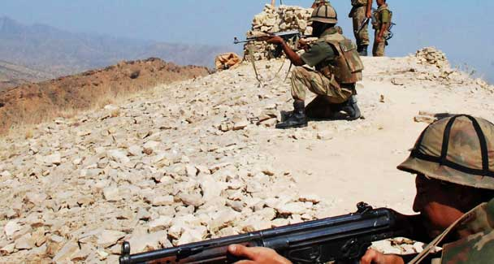
The war being fought in the hills of South Waziristan is not simply a military war; it is more a war of ideas

Now that the military has begun its Rah-i-Nijat operation in South Waziristan, the question has begun to be asked whether it will succeed. We will not know the answer for several weeks, perhaps not even then.
The real victory will come only when the people not just in the tribal areas but in all parts of the country decide that they have been misled by a small of group of extremists.
The people must make clear that they don’t see their country and religion being under assault by the West, in particular the United States, and that it is their own people who are attacking them. In addition to the use of military power, what is required is the use of people’s power. The war being fought in the hills of South Waziristan is not simply a military war; it is more a war of ideas.
There has been much reflection in the American press in recent days about the meaning and ends of war. This was prompted by the on-going review of the options Washington has in the war in Afghanistan. There appears to be consensus among the commentators that no matter what the American president decides regarding the course of the conflict, it will, from now on, be ‘Obama’s war.’
One analyst, Gordon M. Goldstein, writing for The New York Times, drew a number of lessons for the current president based on the experiences of Presidents John Kennedy and Lyndon Johnson in conducting the American war in Vietnam. Kennedy chose the middle course, preferring to concentrate on building the capacity of the state to help the people who had turned to insurgency since they saw no other way to better their rapidly deteriorating economic and social situation. Johnson, on the other hand, was overawed by the military and opted for the military option.
What is the relevance of this debate in the United States for Pakistan’s policymakers as they conduct their operations in South Waziristan? There are several. Of these I would like to focus on the following three. First the civilians must provide credible leadership to this effort by the military. We know from our own history that the military cannot galvanise popular support when it goes into battle to protect the interests of the state.
There was great popular support for troops in the brief war with India in September 1965 but it could not be sustained when the politicians, led by the leadership that had come from the military, were not be able to credibly explain the purpose of the war and its aftermath.
Similarly, while the civil war in East Pakistan was provoked by the military, its aftermath had to be handled by the civilians. In the present context, we should recognise that a good start was made by convening a well-attended meeting of political leaders that authorised the use of force against the entrenched Taliban in South Waziristan.
Second, there has to be only one system of governance in one country. Pakistan allowed the Taliban to run a parallel government in the areas they control. The jihadists in the populous province of Punjab would like to do the same in the areas where they have influence. They will succeed only if the state abdicates its responsibility of providing basic services to the people. This should not happen if the institutions of the state are strong and the government has the resources to provide for the people. The cash-strapped government in Pakistan has to collect more resources to finance its operations and to use the money it spends effectively and efficiently. It is doing neither at this time.
Third, people have also to act. Let me quote at length from a recent article by the journalist Thomas L. Friedman who has written extensively on the developing world, especially on Muslim countries. ‘In places like Egypt, Syria, Saudi Arabia, Afghanistan or Pakistan you have violent religious extremist movements fighting with state security services. … And while the regimes in these countries are committed to crushing their extremists, they rarely take on their extremist ideas by offering progressive alternatives. And when these extremists aim elsewhere … these regimes are indifferent. That is why there is no true war of ideas inside these countries — just a war.’
This is a correct and insightful observation. ‘These states are not promoting an inclusive and tolerant interpretation of Islam that could be the foundation of people power,’ Friedman continues.
Pakistan, unlike the countries on Friedman’s list has had a ‘people power’ movement when the lawyers demonstrated that by acting with courage and resolution, they could bring about more than regime change. They could also force a strong executive to begin to show respect to the judiciary and its opinions. The same people power needs to be mobilised to rescue religion from the clutches of the extremists.
Those on the margins of Pakistani society have found leadership from the ranks of the people who, although basically illiterate and poorly informed, are able to compensate for their shortcomings by the extremely strong courage of their convictions. The lawyers managed to find leaders from their own ranks. The progressive elements within the Pakistani society must search for those who can lead them in a much-needed people’s movement in the war against extremism.
What is needed at this critical moment in the country’s history is a group of civilian leaders who can galvanise broad support for the difficult journey on which the armed forces have embarked. Also needed is an economic plan for building state institutions to deliver the appropriate services to the people in stress and also improve their access to basic needs. Finally the moderates in Pakistani society need to let it be known that they are not in agreement with the extremists in the way they interpret Islam, the way they see the functioning of the state and the way they would place Pakistan in the international community.

