The insensitivity that prevails
By Dr Tariq Rahman
Thursday, 10 Dec, 2009
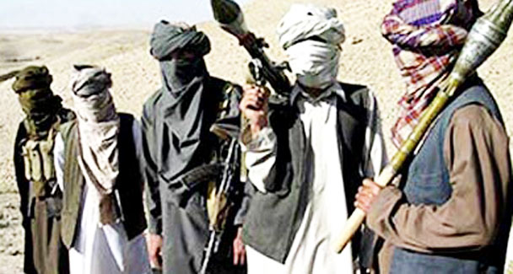
To attack Afghanistan was morally unjustified and a strategically flawed move since one cannot alienate the Pakhtuns in Afghanistan, whose numbers happen to be in the Taliban, and hope to win Afghanistan for Karzai who has no roots in the soil. – Photo by AP.
It’s been an eventful period, beginning with the firing on columnist Kamran Shafi’s home in Wah and ending with Obama’s revised policy on Afghanistan. And less than a week after Eid, the bloodbath began.
Last Friday, terrorists massacred army men and their family members in the Parade Lane mosque in Rawalpindi. Peshawar, Lahore and Multan resounded with bombs and human cries. Nobody can tell what tomorrow will bring.
As for the traumatic incident involving Kamran Shafi, I am appalled that there was no hue and cry at the national level. Why has the journalist brotherhood not risen to defend his right to life and freedom of expression the way it should?
Meanwhile, nobody, except the students and professors of Kohat and Peshawar universities, seem to care for the abducted Kohat University of Science and Technology vice chancellor Dr Lutfullah Kakakhel. A decade ago everybody would have been up in arms at such incidents.
But now that scores of people are dying almost every day have we become insensitive to columnists being fired upon and academics being abducted?
Have we come to this that we reel under attack but do nothing? It seems that the only rally against the daily bloodbath was that of the MQM in Karachi on Tuesday. But within the killing fields of northern Pakistan there is the silence of the grave.
Let us now turn to our real Eid gift — from President Obama. His policy of sending 30,000 more troops to Afghanistan is bad news for us. To attack Afghanistan was morally unjustified and a strategically flawed move since one cannot alienate the Pakhtuns in Afghanistan, whose numbers happen to be in the Taliban, and hope to win Afghanistan for Karzai who has no roots in the soil. Eight years have passed since 9/11 but the Pentagon still feels that it can wipe out the Taliban with more troops.
The greater likelihood is that the Taliban will wait out the months before US troops start to withdraw and then take over southern Afghanistan. Meanwhile more Afghans will cross over into Pakistan; the Pakistani Taliban will be strengthened as the death of innocent people will produce more anger against both America and our own leadership; and, of course, more American lives will be lost.
But the worst thing is that massacres and bombings will continue in Pakistan. Still conspiracy theorists ask inane questions about who the perpetrators are even when the Taliban own their crime. Some say even now that the terrorists cannot be Muslims and that Muslims do not attack mosques, when the recent incident was not the first of its kind.
It is futile to blame India or America. This is our war and the terrorists are fighting us because they want the army to stop action in Waziristan and Swat. If our media people do not say as much they are doing the public no service.
One could argue, of course, about why we blundered into such a war. My view is that Gen Ziaul Haq blundered when he allowed Pakistan to become an ally of the US in its war against the Soviet Union. It was because of this war that radicalised Arabs came to Afghanistan and Fata. It was because of this war that arms and ammunition flooded our society.
Later the militants were used for a covert war against India for Kashmir although many among them also killed members of the Shia community. Our decision-makers accepted that as collateral damage.
Then, when this policy was reversed after 9/11, the same groups started fighting the Pakistan Army. Yet another blunder was Gen Musharraf’s decision to become an American ally in the war against Afghanistan. Again, as when under Zia, we did not stay aloof from a terrible war which we might have avoided.
Pakistan should have stayed away from all wars — the 1948 Kashmir war, the 1965 war, the 1971 war, the first Afghan war, the covert war in Kashmir, Kargil and the second Afghan war — and remained neutral. In that case we would not have had Taliban enemies.
What are we to do now? First, we must support our armed forces, FC, police and guards who are dying in their hundreds. Even if some decision-makers from the military made the policies that unleashed the dogs of war upon us, it does not mean we should not sympathise with the families of those who have sacrificed their lives for us. We should salute them.
I know some people, old comrades, who were wounded in the Parade Lane mosque bombing and I express solidarity with them even if I have disagreed with some of the policies they supported in the past. Our human relations take priority over our ideological positions.
Secondly, efforts should be made to remove the confusion about who our enemies are. There is a lot of evidence that militants taking the name of Islam are fighting our army so why should people be confused and point to foreign powers?
In this context India and Afghanistan can help us and themselves by fighting the militants. India should simply withdraw from Afghanistan because if the anti-India Taliban become stronger in Pakistan, India will be in great danger.
All these Indian consulates, which probably supply arms and ammunition to Baloch nationalists, will eventually be doing the same kind of disservice to India as our own intelligence services did by strengthening the militants in the first place.
After the American withdrawal it is a foregone conclusion that the Taliban will control part of that country. In that case we should be strictly neutral and not allow our soil to be used by any armed group. So should India and this is both in India’s interest and ours.
A proxy war between India and Pakistan in Afghanistan will destroy both. India can negotiate with Pakistan, which is a modern state after all, but not with the Taliban. A stable and strong Pakistan is in India’s interest as it is in America’s.

