The military’s ideology
By Ayesha Siddiqa
Friday, 25 Sep, 2009 | 08:21 AM PST
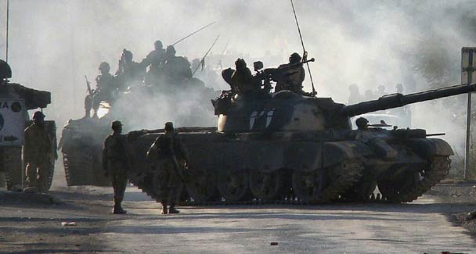
The country’s ruling elite and the military have traditionally used a particular aspect of religion to gain strategic dividends. —File Photo
PAKISTAN observers often wonder what the Pakistan military’s primary ideology is. Is it a secular institution or one which is high on religious values? Since the military is considered the strongest institution of the Pakistani state, the question becomes critical in determining what direction the country will take or how its armed forces will fight the war on terror.
One particular perspective is that the military is essentially a secular institution which got transformed temporarily under Gen Ziaul Haq, who made sure that his officers had a religious grounding. He had allowed the tableeghi jamaat to penetrate the armed forces and introduced a religiously conservative current in society. Subsequently, the Zia era was blamed for the continued links between certain military personnel and the Taliban post-9/11.
Later, it was argued that Gen Pervez Musharraf put the military back on the secular track by weeding out religious-minded, senior officers replacing them with others who were socially acceptable to the international community. In fact, senior officers now claim that the military is highly professional and secular. This is correct in that ‘secular’ in this case means that the army is not driven purely by religious instincts in pursuing its goals. But then ‘religious’ or ‘secular’ are not the right terms to describe the organisation.
Indeed, if one is searching for the correct term, it would be pragmatic-nationalist. This means that instead of sticking to one ideology the institution can shift between a couple or more ideologies at the same time. So, when it was convenient to turn religiously ideological during the 1980s it could do so. Even Gen Zia was not solely driven by his personal inclination to support the Afghan ‘jihad’; the geo-strategic and geopolitical environment was important in the framing of decisions. There was no dichotomy between pursuing jihad and having a strategic alignment with the US even then.
Zia also found religious ideology handy in pursuing other military-strategic goals. Deploying non-state actors was financially, politically and militarily cost-effective. Hence, all generals maintained links with the jihadis despite the fact that they were different from Zia.
The pragmatist-nationalist character of the military also explains why it was able to swiftly shift between ideologies, especially after it had to undergo a change in the wake of 9/11. This also means that maintaining links with the different jihadi organisations, as explained by Arif Jamal in Shadow War: the Untold Story of Jihad in Kashmir, does not necessarily depend on having a religious ideology.
The author’s interesting conclusion is that even seemingly ‘secular’ generals like the present chief, Gen Ashfaq Kayani, could pursue the same policy as the generals during the 1990s. Jamal claims that a lot of jihadi organisations were thrilled to hear of the appointment of Gen Kayani as the new chief and many reopened their offices in 2008. He also argues that several meetings were arranged between the various Afghan Taliban groups and the Kashmiri jihadis in 2007 by the ISI to help them with a strategy to stop Indian help from reaching Hamid Karzai’s government in Kabul and placing more sleeper cells in India for possible activation at later dates.
This argument explains the character of the Pakistan Army and its use of religion or at least one aspect of it, namely jihad, for its strategic advantage. There is nothing odd in the argument since the military was part of what was described by Hamza Alavi as the Muslim salariat class, which used religion to motivate a movement for an independent state.
The fact is that this class was always linked to the use of religious ideology. It might not want to adopt a Saudi model for state-making, though the Pakistani state has gradually moved closer to Saudi Arabia, but religion has always remained central to the fulfilment of the strategic goals of the salariat, which later evolved into the ruling elite.
This basically meant that while the Islamic norms of social justice might not be adopted, religious identity would be used in some form to meet political and military-strategic objectives. Jamal’s argument is that like all such plans that generate opportunity costs, the jihadis of today, who seem to be challenging the Pakistani state, are inadvertently a product of a specific plan to fight the war in Kashmir.
The camps where Ajmal Qasab and others were trained by the Lashkar-i-Taiba to carry out the Mumbai attacks, the author claims, were set up by the ISI to win the war in Kashmir. Even if the attack was not ordered by the intelligence agency, it indicates a situation where the jihadis trained for a particular purpose might have used their training to carry out attacks on their own or gone beyond the brief.
Obviously, the military always had to use religion as a motivating factor from the time when Col Akhtar Malik planned the first offensive to capture Kashmir in 1947/48 to the 1980s and 1990s when, according to Jamal, a lot of new jihadi organisations were established. Gen Ayub Khan adopted a similar approach while planning the historic but failed Operation Gibraltar in 1965. However, the military was not the only force which used the above-mentioned approach.
Even seemingly liberal-secular leaders like Zulfikar Ali Bhutto favoured the policy of using non-state actors to the country’s perceived military advantage. For instance, Bhutto personally came to congratulate the hijackers of an Indian Airlines flight in January 1971. It is important to remember that the use of non-state actors was part of a larger package of mixing religion with state strategy.
In adopting this approach Bhutto might have not been too far off from Ziaul Haq who, as Jamal argues, developed an alignment with the Jamaat-i-Islami to support the Afghan jihad and to use that as a cover for strengthening the army’s war in Kashmir.
The country’s ruling elite and the military have traditionally used a particular aspect of religion to gain strategic dividends. While they can conveniently claim to have retained their secularism and saved one organisation from turning ideological, a similar claim might not be made for society at large. The proliferation of ‘jihad’ in mainland Pakistan is but the opportunity cost of strategy.

