Tomorrow’s army
By Ahmad Faruqui
Monday, 26 Oct, 2009
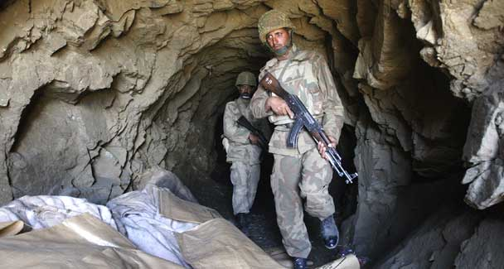
‘Of course, war could also break out if Pakistan’s future leaders, whether civilian or military, embarked on another misguided adventure.’

In my last article, I reported on my discussion with Col (retd) Brian Cloughley, a historian of the Pakistani Army, about the latter’s combat effectiveness. In this article I conclude that conversation by talking about the army’s future.
I asked him whether the army will be facing the same threats five years out as it does now. After protesting that he did not have a crystal ball, he noted that terrorism will continue to be a threat ‘and there will almost certainly be a continuing requirement for the army to police the Federally Administered Tribal Areas and the Northwest Frontier Province. As to the Indian threat — who knows? The nationalist extremists are now on the outer in India, but this could change. And the Indians are resolutely refusing to engage in dialogue, so there can be no dropping of guard’.
I asked if a time would come when Indians and Pakistanis will have routine exchanges of general officers and maybe even hold joint training exercises. After all, no less a military figure than President Field Marshal Ayub Khan had offered a joint defence pact to President Nehru in the late 1950s.
Brian said he very much doubted it and reminded me that Nehru had countered Ayub by saying: ‘Joint against whom?’ He said Nehru thought he was being clever but instead he was being arrogant and short-sighted. A real opportunity for peace was lost and increasing friction between the two siblings ultimately led to war in 1965.
I noted that Ayub Khan not only skipped the war in his memoirs, Friends, Not Masters, he also skipped it in his diaries which cover the period from 1966 to 1972. Brian said that he was not surprised by the omission: ‘It was a very poorly planned war. Operation Gibraltar was a shambles, to begin with.’
Ayub Khan, who had boasted that Pakistan was the Prussia of the subcontinent, knew that better than anyone else but his ego would not let him admit to the fact. This is borne out in a book written by G.W. Choudhury, one of the general’s cabinet ministers. In The Last Days of United Pakistan he says he met Gen Ayub when the latter was in the US for medical treatment after being deposed from power.
Choudhury says he asked him whether the usual procedure for debating both sides of the issue had not been followed with respect to the crucial decision to launch the war in Kashmir. The general answered: ‘Please do not rub in my weakest and fatal point.’
Returning to the army’s future, I asked Brian if the force structure, training regimen and equipment inventory of the army were adequate for dealing with changing threats. He said the army was flexible enough to cope with changing circumstances but that such changes would require time. He said even the US army was finding it difficult to change with changing circumstances, as seen by its performance in Afghanistan and earlier in Iraq.
Turning to the issue of Kashmir, I asked Brian if the army had finally concluded that it was a bad idea to keep on fighting a proxy war in Indian-held territories. He said he did not know for sure but was confident that under Musharraf the army had stopped supporting militants such as those of the Lashkar-i-Taiba ‘for good in 2002’.
Since Pakistan’s military failures can all be traced to poor generalship, I asked the army’s leading historian what criteria were used to promote general officers. He said that normal criteria were used such as competence, flexibility and good command record. Also, he said, ‘card-carrying fundos’ had been told to not bother applying.
A key unknown is whether the army, with its British heritage, will begin to resemble the American army with whom it has been engaged in a variety of cooperative endeavours during the past few years.
Brian seemed to think so, saying that the Americans were very keen to have it resemble the US army. He noted the Pakistan Air Force had already changed its badges of ranks and that younger officers in all services would like to go the American way in order to acquire the modern look.
I asked him if any obvious changes were going to occur in the Indian army during the next five years. He said the Indian army was short by 13,000 officers and that it may seek to eliminate that shortage but the cost could be prohibitive and it was becoming difficult to recruit junior officers. He also expected that army to improve its communications and domestic arrangements.
Since so much of the future depends on the quality of instruction, I asked him to comment on the curriculum at the Pakistan Military Academy (PMA) in Kakul. He said it was very good and that the PMA was a well-run and efficient place. Turning to the Command and Staff College in Quetta, where mid-level officers are trained, he said it was a world-class institution with one weakness: ‘A tendency to go for what we call the DS (Directing Staff) solution rather than take the risk of indulging in original thought.’
He added that the National Defence University, where flag officers were trained, was excellent, with ‘some first-class brains and thoroughly professional coursework’. And he was very complimentary of the faculty of contemporary studies.
In closing, I returned to Pakistan’s longstanding problem with India and asked whether a change in attitude on Pakistan’s part, especially on Kashmir, would change the military dynamic between the two countries. He quipped that he ‘would like to think that waving a wand over Kashmir would instantly create sweetness and light between India and Pakistan, but the legacy of 60 years of distrust — hatred, really — cannot be eradicated.’
Brian added that as best as he could tell, only businessmen on both sides seem interested in having normal relations between the two countries. In the present circumstances, he seemed to think war was unlikely but if the hard-core nationalists prevailed in India, a future war could not be ruled out. Of course, war could also break out if Pakistan’s future leaders, whether civilian or military, embarked on another misguided adventure.
The discussion concluded on a dour and dank note: ‘The development of nuclear weapons by both countries was supposed to be a deterrent but if a war breaks out, it will deter no one. It [is] doubtful that either nation would alter its current policy towards the other. The guns will stay in position while people starve.’

