Unseemly claims
By Anwar Syed
Sunday, 24 Jan, 2010
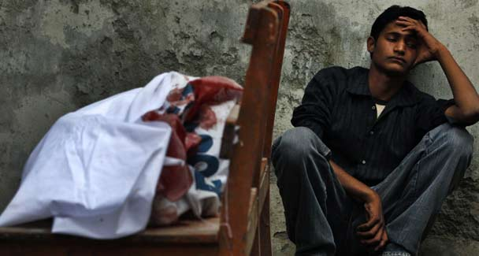
Ajmal sits next to the body of his brother, who was killed in a bomb blast in Rawalpindi, at the morgue in a hospital in the outskirts of Islamabad, November 2, 2009. — Reuters
A man amongst the many who had assembled to mourn Benazir Bhutto’s death yelled out that Pakistan would not last. And then Asif Ali Zardari shouted “Pakistan khappay”, meaning it would.
Since that day in December 2007 — Zardari has projected himself as the protector of Pakistan, democracy, the PPP, and the many legacies of Zulfikar Ali Bhutto and Benazir Bhutto. More recently he also stated that no one will be allowed to undermine the country’s armed forces. It should, however, be noted that he is not alone in making such claims; other politicians have also tried to appropriate the status of preserver of Pakistan and its institutions. In all of these cases, the claim is a gross exaggeration. One is likely to hear in drawing rooms, saloons, and even roadside tea shops that America and, to a lesser extent, the UK, possibly in an alliance with India plan to undo Pakistan. This is loose talk.
There has been little interaction between the people of Pakistan and the people of these western countries. It is their governments that have done business with each other. Except for a couple of brief interludes, governments in Pakistan have looked to successive American administrations as their patrons, done errands for them and got paid for services rendered. This continues to be the case. As expected, the patron has been dominant and at times even arrogant.
Most people in Pakistan are resentful of American attitudes. This state of public opinion may have induced Prime Minister Gilani to assert Pakistan’s independence and sovereignty in the National Assembly the other day and declare that, in return for American assistance, Pakistan will not bargain away its dignity and honour. It remains to be seen whether Gilani’s high-sounding declarations were meant and taken seriously.
I have a feeling that they were not, and that the patron-client pattern between the American and Pakistani governments will remain operative. The UK has not been very demanding in its transactions with Pakistan and the relationship has been one of cooperation in a quiet sort of way.
We encounter a radically different situation when we look at Indian attitudes towards Pakistan. It would probably be an exaggeration to say that India wants Pakistan to disappear from the world map of independent states. Its ruling politicians insist that they want Pakistan to become a progressive, democratic, stable and prosperous state. This claim is also an exaggeration — the fact remains that India wants to be recognised as the dominant power in South Asia and, as such, it would like to dominate Pakistan. If Pakistan defies its dominance and disputes its hold on Kashmir, India will attempt to disrupt Pakistan’s internal order. But India’s hostile attitudes and moves will not destroy Pakistan.
Pakistan has of late become a very uncomfortable place to live in; not only for the poor but even for the middle classes. Folks go without gas and electricity for long hours every day. Sugar is in short supply as are many other food items, including the staples and vegetables. Prices are sky high and they have made it difficult for the ordinary individual to simply stay alive. Small towns and villages all over the country cannot even boast of as basic an amenity as safe drinking water. It may not be possible for the managers of state and society to eliminate these shortages, but they can surely be alleviated to some degree.
Domestic grievances, alienation, and insurrections pose a greater threat to Pakistan’s integrity than any foreign machinations. These grievances arise not only from the aforementioned shortages but from the sense in the country’s smaller provinces that their interests are overlooked and compromised as compared to the others, that their resources are utilised without adequate compensation and used for the benefit of outsiders. They want autonomy in managing their affairs and control over their resources.
All political parties and successive governments in the country have acknowledged the validity of these grievances and endorsed the idea of provincial autonomy. Yet, when in power, none of them, including the present government, have done anything to meet the aggrieved people’s demands.
We have had a few reasonably effective governments since 1947. More of them were wanting in both honesty and efficiency. We now happen to have a government whose leaders — Asif Ali Zardari and Yousuf Raza Gilani — are known more for their loquaciousness than for reports of missions accomplished. Those who are given to excessive talking are often reckless in their choice of words and end up saying things that are unwise or even downright foolish. Mr Zardari and Mr Gilani are no exceptions to this rule.
Their disinclination to act is weakening the country. The private domain is doing well, but the public domain is almost entirely stagnant. Nothing is moving forward. Public enterprises are sinking under the weight of pervasive corruption. The breakdowns in law and order have reached a point where a citizen’s life and property are in constant jeopardy. Mr Zardari and Mr Gilani seem to be doing nothing to ameliorate any of these frustrations.
One may wonder what the prime minister will do to maintain this country’s honour and dignity in dealing with American officials. He says his government will not tolerate America’s drone attacks in tribal areas because they violate Pakistan’s sovereignty. Mr Carl Levine, chairman of the United States senate committee on the armed services, says these attacks are being made with the privately conveyed consent of the government of Pakistan.
President Zardari said a few days ago that he and President Obama agreed on a whole range of American actions in Pakistan including the drone attacks. Several American officials, including President Obama, have made similar assertions. America is satisfied with its relationship with Pakistan and it has no reason to have this country disrupted. But the likelihood is that the patron-client relationship will continue. Mr Gilani’s resounding declarations of Pakistan’s honour and dignity will remain words that were spoken because they sounded good.

