Using checkpoints to beat urban terrorism
By Ranga Kalansooriya
Saturday, 13 Mar, 2010
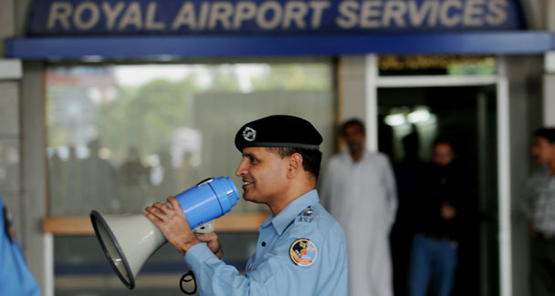
A police officer of The Pakistan Airport Security Force (ASF) uses a loudspeaker at Islamabad International Airport.
I was driving in Islamabad with my wife in the front seat for over a month passing dozens of checkposts, but never were we ordered to stop. Whenever we were approaching a checkpoint, my wife would ask me “would we be stopped?” If it is night, I would put on the hood-light, the police see my wife – sometimes shed a nice smile towards her – and would always let us go. “That is the case mostly when you are with a lady,” my Pakistani friends would explain to our surprise.
Oh God! Aren’t there women terrorists in this part of the world? Don’t they know it was a woman suicide bomber from Tamil Tigers who killed the Indian Prime Minister Rajiv Gandhi?
Once I walked through a heavily guarded checkpoint in Blue Area, expecting to be stopped because of my heavy backpack. No, I did not attract even a quizzical look. Maybe the instructions were only to check vehicles.
My thoughts went back to my experiences at checkpoints in Sri Lanka in its turbulent years. There authorities took care that no loophole was left in the security set up for the ingenuous Tamil Tiger attackers to infiltrate into capital Colombo or other major cities.
“Terrorists are always innovative and one step ahead. We must think as a terrorist if we are to stop them with precautionary measures,” General Tennekoon who was once in-charge of trouble-ridden Jaffna told me long ago.
But is this strategy being implemented here in Pakistan?
At the height of the Tamil Tiger insurgency, the Sri Lankan Supreme Court upheld a fundamental rights petition against the irksome checkpoints in Colombo and ordered police to remove them immediately.
But the ruling was never implemented. The silent message was: “Let us remove them after the war. First we need to protect the life of human beings, before protecting their rights.” The Tamil Tigers were vanquished last May but the checkpoints are still there. Though the war in Sri Lanka was being fought far away from the capital — mainly in the northern and eastern parts of the country – the Tamil Tigers inflicted the worst wounds on their adversary by targeting high profile political and military figures and economic, political and security establishments in Colombo and other cities.
And even tough checkpoints could not completely stop their suicide bombers and attackers from sneaking into urban areas and wreak havoc, but the effort did act as a major psychological deterrent.
At a checkpoint in Colombo, you had to be lucky to be cleared within seconds like in Islamabad. You will be put through a process of cross checking your identity and examining your vehicle – sometimes checking the fuel tank as well as the Tigers used to transport explosives hidden inside the fuel tank.
Then there were mobile checkposts. You never know when and where the next checkpoint would be. People initially found it a headache, but the security personnel at the checkpost would very politely explain the ‘harassment’ was for your own safety. They were professionally trained to be tough only when really needed.
My experience in Pakistan was different, though.
I was passing a walk-through gate at the Karachi International Airport to take my Sri Lankan airline flight home when the alarm of the machine went off. I had removed all metal items from my person as required but my bracelet was there on my right hand. The guard carrying a metal detector ordered me to remove the bracelet.
“Sorry, I cannot. This is a religious thing. I cannot remove this,” I told and asked him to body-check me. But he wouldn’t, insisting that I must remove the bracelet, or miss the flight.
Our heated argument brought a senior officer to us. I invited him to a corner and started sharing some experiences. “The recent Kenyan suicide bomber never carried metal with him on board – only a mix of chemical non-metallic powder – may be around 200 grams – in his underpants. Please tell me sir, how is your colleague going to find out with his metal detector whether I am carrying explosive powder in my underpants?”
That settled the matter. The officer ordered the guard to body check me with his hands. Reluctantly he obeyed. It was then the officer who called me to a corner. “Sir, are you from Sri Lankan security forces?” he asked.
“No I am a civilian with common sense. Please advise your colleagues to trust their senses more than the machines since these could sometime deceive you. This is common sense,” I told him and walked off.
Sri Lankans love Pakistan for the help she rendered during the war against Tigers. It is high time that Pakistan, too, learnt some lessons from Sri Lanka’s long experience in combating and defeating terrorism. After all no one else has been able to do that in the region so far.

