What the future may hold
By Iqbal Jafar
Thursday, 14 Jan, 2010
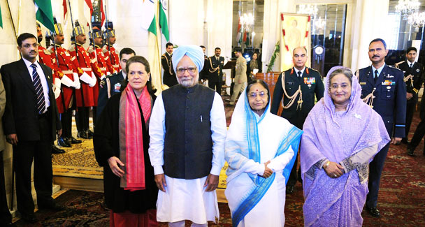
Indian President Pratibha Patil (2R) poses with Bangladesh PM Sheikh Hasina (R) after presenting her with the Indira Gandhi Award for Peace, Disarmament and Development for 2009, UPA Chairperson Sonia Gandhi (L) and Indian PM Manmohan Singh (2L) at The Presidential Palace in New Delhi on January 12, 2010. – Photo by AFP.

World
India’s unhelpful attitude

India’s unhelpful attitude

To have an idea about what the future may look like — as seen from Washington, Delhi and Tel Aviv — it seems we have to see through the prism of the Indian establishment, Israeli hardliners and American neocons who wield significant influence on their governments.
Their worldviews are structured around their geopolitical ambitions that they make no effort to conceal. The Indian establishment dreams of being the hegemon of South Asia and the adherents of Zionism of the Middle East. As for the neocons, the world is their oyster, or so they insist.
This may seem ambitious enough, but there’s more — the regional hegemons, India and Israel, have an extended South Asia and Middle East in mind. As Israel Shahak, a highly regarded Israeli scholar and human rights activist, has pointed out, the subject of Israeli domination and influence is “the entire Middle East from Morocco to Pakistan”. Indian scholars and strategists from Sardar K.M. Panikar to Gen Deepak Kapoor consider the Indian Ocean their own (hence a blue-water navy), along with the region from the Persian Gulf to Malacca Strait to be within the Indian sphere of influence.
While the Indian establishment and Zionists are almost synonymous with their respective governments, the neocons are not that powerful in the Obama administration. But surprisingly, their imperial goals still remain a part of American foreign policy. The best that the Obama government has been able to do is to walk briskly on both sides of the street. This is understandable. Impelled by the peculiar dynamics of a superpower, no American administration can roll back the imperial impulse that always finds a place in the worldview of a big power. Even George Washington had referred to the United States as a ‘rising empire’ in March 1783.
While US-Israeli and Indo-Israeli partnerships have existed for a long time, the Indo-US partnership came into fruition only last year and is likely to be more important than the other two. As William Burns, the US undersecretary of state for political affairs, said recently in a policy speech: “Few relationships will matter more in the course of human events in the 21st century than the partnership between India and the United States.”
One may wonder about the future repercussions of the present course of human events and the impact of Indo-US ties, but it can be taken for granted that old and new partnerships will, before long, coalesce into one triangular alliance in pursuit of their common goals in the Middle East, Central Asia and South Asia. For all we know this may have happened already.
Now, where do we figure on the vast canvas of the allied powers? Well, we happen to occupy a critical spot on it; where their interests converge. These interests are well known but need to be enumerated here to complete the picture. Their first common interest is to denuclearise Pakistan. Second is to eliminate militants. Third is access to Afghanistan and Central Asia through Pakistan, in which the United States has a special interest as a major player in the New Great Game. Fourth is of special interest to India — persuading or coercing Pakistan to accept Kashmir’s accession to India or at least of the area under Indian occupation.
Then there is an intriguing fifth common interest also — the creation of an independent state of Balochistan, an idea that has been in gestation since before the creation of Pakistan. In May 1945, the post-hostilities planning staff of the British war cabinet had recommended stationing “military strategic reserve” to protect sea communications in the Persian Gulf and the Arabian Sea as they were of “great strategic value”. It was argued that: “Central Headquarters India has suggested Balochistan as an alternative to India proper, on the grounds that it may be relatively easy to exclude this territory from the Dominion of India.”
Some two years later, on Aug 12, 1947, the Khan of Kalat proclaimed the independence of the state of Kalat, comprising the entire Baloch part of Balochistan. The demand for separation and independence has since been a recurrent theme in the politics of Balochistan and has been reiterated by the present Khan of Kalat. Incidentally, he has been living in London for many years now.
The Indian interest in Balochistan was made public when Indira Gandhi, in her victory speech after the fall of East Pakistan in 1971, assured Baloch “brothers” that India had not forgotten them. Now, 38 years later, there are good reasons to believe that the Indian establishment has indeed not forgotten them. The US interest in Balochistan is reflected in various speculations about the future geographical contours of Pakistan, complete with maps, in the US media. Balochistan, thus, remains an important piece on the chessboard of the New Great Game. There are three primary reasons why the idea of an independent state of Balochistan appeals to some strategists in the US and elsewhere. First, it will be far easier for multinationals to exploit the fabulously rich resources of a weak and poor state of ethnic Baloch people — the population is less than five million and the per capita income under half a dollar a day.
Second, it is suitably located for naval and other military bases to complete the chain of existing US bases that stretch back to Afghanistan and Central Asia. This will provide a protected outlet for an oil pipeline from Central Asia via Afghanistan. It will also bypass an already hostile Iran and a potentially hostile and otherwise volatile Pakistan. The bases could also be used to launch an overland assault on Iran’s south-eastern coast, opposite Oman, to consolidate control of the Strait of Hormuz, the Achilles’ heel of the world economy. Lastly, as a less lethal option, an independent state of Balochistan can be used as a launching pad for a greater Balochistan movement, not only to keep Iran in check but also to make it vulnerable to ethnic fragmentation. Thus, Balochistan as a separate entity offers many temptations to allied powers.
This is what the future holds when viewed from the ever sharpening Indo-US-Israeli focus on our land. And an impending mortal combat, mandated by fate and geography can only be resisted and survived if we stand united under a dedicated leadership. It is as simple and, let’s concede, as problematic as that.
iqbal.jafar1@yahoo.com

